Multivariate Statistics
Assignment 1 – Team 13
FACULTY OF SCIENCE
Academic year 2026-2027

Prof. Michel Meulders
KU Leuven

Delphine Seghers, r0993707
Felix Mitterer, r0689370
Max Lambert, ...
Tijl Cresens, ...

Task 1

PCA on Standardized Variables and Horn’s Procedure
Before the analysis, we reverse-coded three items (hmsfmlsh, rlgatnd and pray) so that, within each concept, a higher score indicates more of the concept it measures. The three items on gays and lesbians therefore measure a negative attitude towards gays and lesbians. We then checked the 16 items for missing values: none were found, so all 30 countries were retained. Then, we standardised the data because the items were measured on different scales (0–10, 1–5, 1–7 and 0–6). It follows that the total variance of the data is 16.
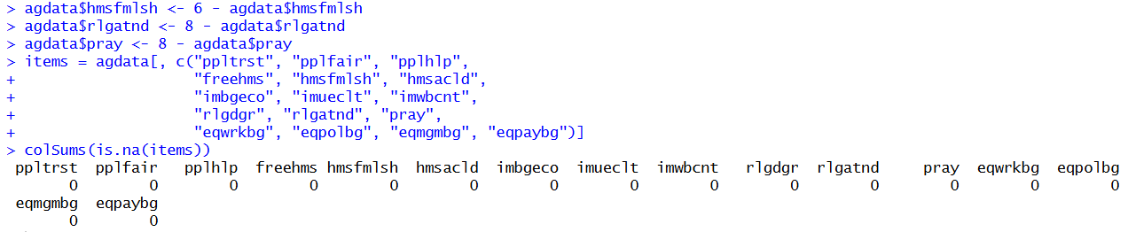
Next, we performed a principal component analysis, which can be interpreted as the eigendecomposition of the correlation matrix, and obtained the eigenvalues, the proportion of variance explained by each component and the cumulative proportion of explained variance. The first component has a very large eigenvalue (10.66) and explains approximately 67% of the total variance in the data. The second and third components have eigenvalues of 2.26 and 1.28 and explain 14% and 8% of the variance, respectively. From the fourth component onward, the eigenvalues are below 1 (0.70 and smaller). The first two components together explain 81% of the variance.
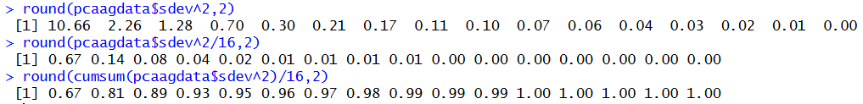
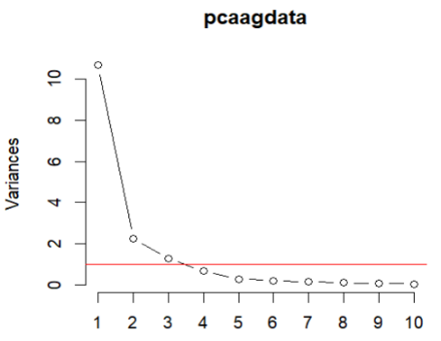

We then constructed a scree plot to determine how many principal components to retain. The scree plot shows an elbow at the second component, which suggests retaining one, or possibly two, components. Using Kaiser’s rule, which retains the components with an eigenvalue greater than 1, three components should be retained. After the third component, the eigenvalues drop below 1, indicating that the subsequent components explain less variance than a single standardised variable.
Horn’s procedure, however, is a better method for determining the number of components to retain, because it retains only components that capture more than chance variation. We applied Horn’s procedure, using both the mean of the bootstrapped eigenvalues and the more conservative 95th percentile. With the mean criterion, the observed eigenvalues exceed the mean random eigenvalues only for the first two components: their adjusted eigenvalues (9.13 and 1.12) are greater than 1, so two components should be retained. The adjusted eigenvalue of the second component, however, is only just above 1. With the 95th percentile criterion, only the first component has an adjusted eigenvalue greater than 1 (8.77), so only one component should be retained. In the remainder of this exercise, we therefore present both the one-component and the two-component solutions.
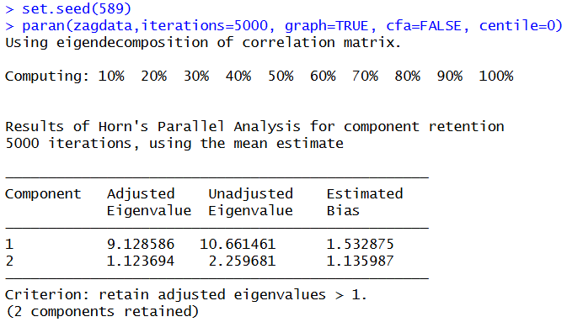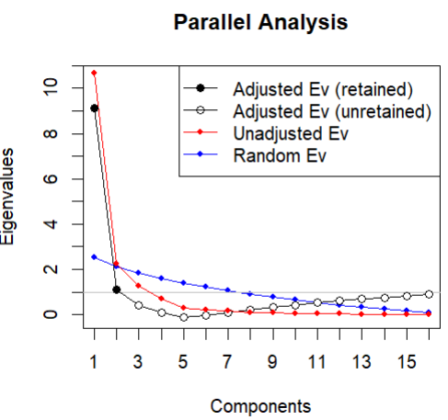
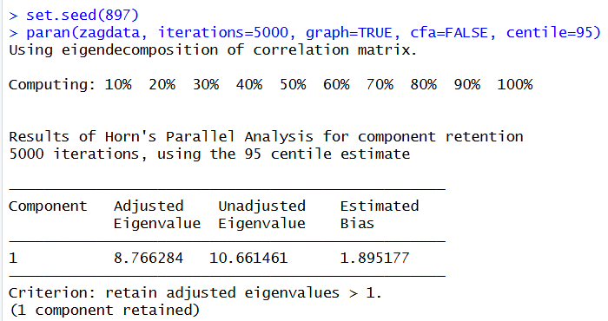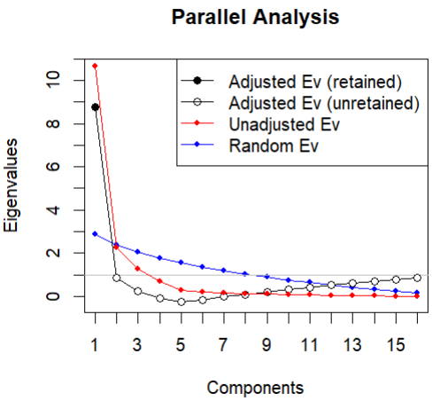
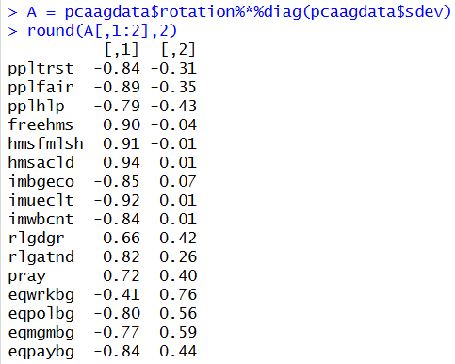
Next, we computed the component loadings to interpret the principal components. Because the variables are standardised, the loadings are the correlations between the items and the components. PC1 is a general dimension on which 15 of the 16 items load substantially; only eqwrkbg has a weaker loading (−0.41). The social trust, positive attitude towards immigrants and positive attitude towards gender equality items load negatively, whereas the negative attitude towards gays/lesbians and religiousness items load positively. The strongest loadings are those of hmsacld (0.94), imueclt (−0.92) and hmsfmlsh (0.91). A high score on PC1 therefore indicates lower social trust, a less positive attitude towards immigrants and gender equality, a more negative attitude towards gays/lesbians and higher religiousness; a low score indicates the opposite. On PC2, the positive attitude towards gender equality items load positively (0.44 to 0.76), the religiousness items moderately positively (0.26 to 0.42) and the social trust items negatively (−0.31 to −0.43), while the gays/lesbians and immigrants items hardly load on PC2 (−0.04 to 0.07). A high score on PC2 therefore indicates a more positive attitude towards gender equality, somewhat higher religiousness and lower social trust; a low score indicates the opposite.
Finally, we calculated the proportion of variance accounted for (VAF) in each variable by the first component and by the first two components. These results support retaining two principal components. With one component, the VAF is low for eqwrkbg (0.17) and for the religious items rlgdgr (0.44) and pray (0.52). These low values disappear when two components are included.
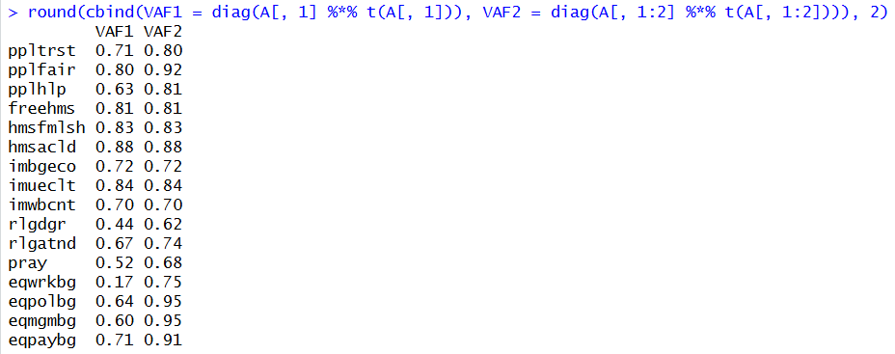
In conclusion, it is best to retain two components, which together explain 81% of the variance. This choice is supported by Horn’s mean criterion and the VAF per item, but we should take into account that the 95th percentile criterion reminds us that PC2 is borderline.
- Biplot
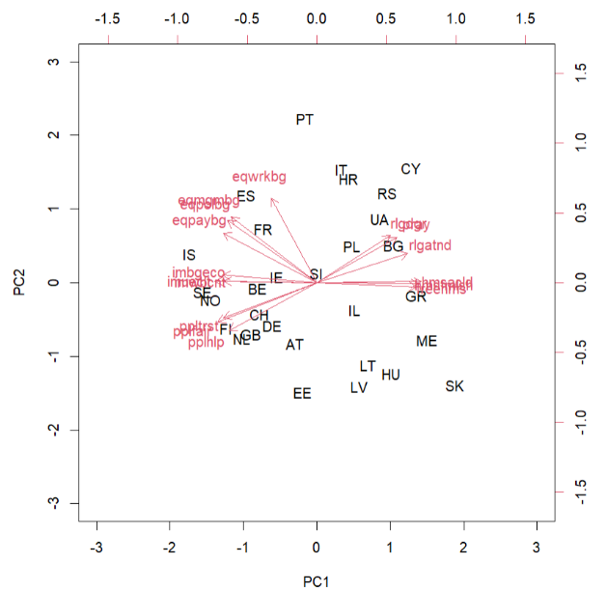
The biplot represents the 30 countries by their standardised component scores and the 16 items by their component loadings on the first two principal components. Countries that lie close together have similar scores on PC1 and PC2. The biplot does not give a perfect representation of the data, because it only takes the first two principal components into account, which together explain 81% of the variance. Although the approximation is not perfect, it is fairly close.
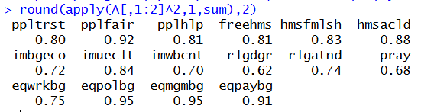
The squared length of each vector in the biplot represents the proportion of that variable’s variance accounted for by the first two principal components. All gender-equality items are well represented, with eqpolbg and eqmgmbg having the longest vector and thus the largest proportion of variance accounted for (0.95). At the other end, rlgdgr has the shortest vector and the smallest proportion of variance accounted for (0.62). However, even the smallest values are relatively large, so the plot can be interpreted for every item.
The angles between the vectors demonstrate the predicted correlations between the items. Items that measure the same concept point in roughly the same direction, so they are positively correlated with each other; the strongest correlation is between eqpolbg and eqmgmbg (0.95). The social trust, attitude immigrants and attitude gender equality items all point to the left, whereas the items measuring a negative attitude towards gays and lesbians point to the right, close to the religiousness items. The gays/lesbians items therefore point nearly opposite to the immigration and trust items, which gives the most negative predicted correlations (down to −0.86 for imueclt and hmsacld): countries with more positive attitudes towards immigrants and more social trust tend to have less negative attitudes towards gays and lesbians. Likewise, the religiousness items point nearly opposite to the trust items (down to −0.83 for pplfair and rlgatnd). The gender-equality items are moderately positively correlated with the trust items (0.36 to 0.60) and negatively correlated with the religiousness items (−0.26 to −0.57). The exception is eqwrkbg: its vector is almost perpendicular to the trust and religiousness items, so how positive a country is about women in paid work is nearly unrelated to its level of social trust or religiousness.
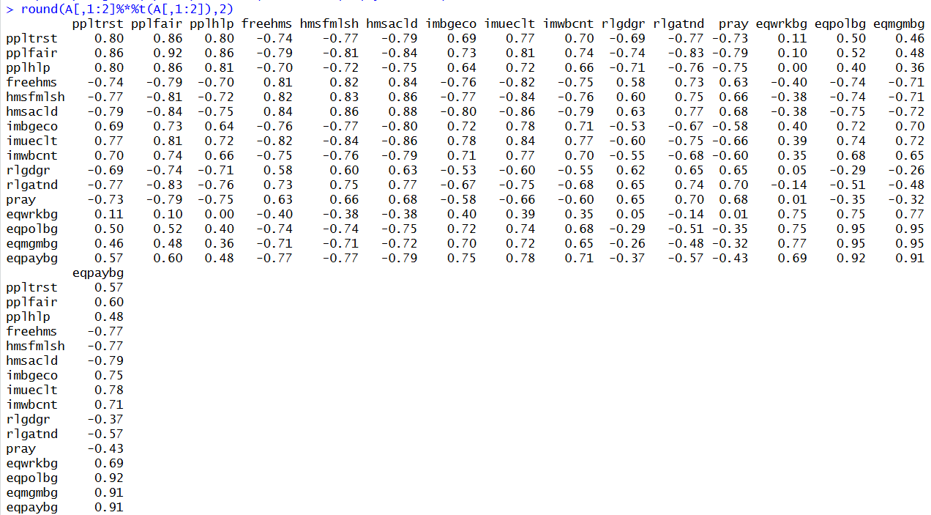
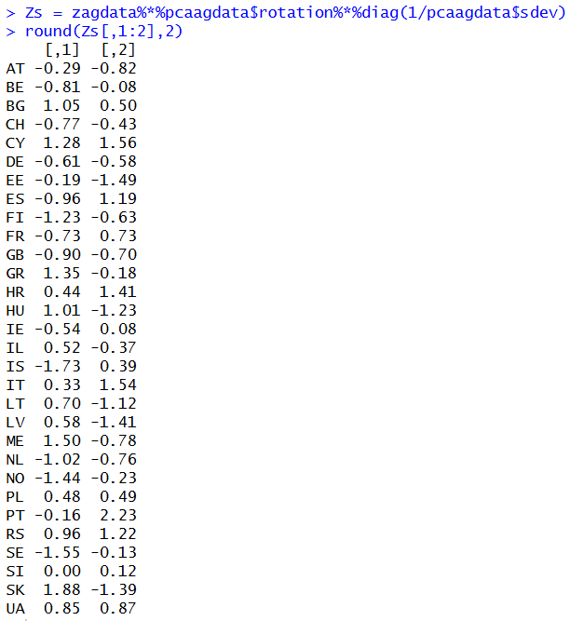
Finally, we computed the standardised component scores to determine which countries score high and low on each principal component. On PC1, the Nordic countries (IS, SE, NO, FI) and the Western European countries (BE, NL, GB, CH, DE, IE) lie towards the left, in the direction of the social trust, gender-equality and immigration vectors and away from the vectors of negative attitudes towards gays and lesbians and religiousness. SK, ME, GR, CY, BG, HU and RS lie towards the right, with the opposite characteristics. On PC2, Portugal (PT) has the highest score and lies in the direction of the gender-equality vectors (especially eqwrkbg), whereas Estonia (EE) has the lowest score. More generally, the Southern European countries (PT, IT, HR, ES) score high on PC2 and the Baltic and Central European countries (EE, LV, LT, HU) score low. Relative to their position on PC1, the former are more positive about gender equality, more religious and less trusting, whereas the latter are less positive about gender equality, less religious and more trusting.

Task 2

EFA on standardized variables with oblique rotation
After loading the data and reverse-coding the items hmsfmlsh, rlgatnd, and pray to ensure consistent orientation, we checked the dataset for missing values before computing the correlation matrix of the 16 items. Since no missing values were detected, all observations were retained for the analysis. The complete preprocessing code is included in the accompanying R script.
The factor analysis was performed on the correlation matrix, which already represents the relationships between standardized variables. This is equivalent to conducting the Exploratory Factor Analysis (EFA) on explicitly standardized variables. EFA aims to identify the underlying factor structure without specifying beforehand which observed variables (items) measure which factors. Hence, in EFA, each observed variable is allowed to load on all five factors, rather than being restricted to a single predefined factor. This contrasts with Confirmatory Factor Analysis (CFA) (see task 2b), which tests a predefined factor structure by specifying which variables measure each factor. Hence, in CFA we test whether certain items effectively measure certain concepts.
Here, EFA was conducted on the correlation matrix of the 16 items, using maximum likelihood estimation, five factors, and oblique rotation, which allows the factors to be correlated with one another rather than assuming that they are uncorrelated. As shown in the EFA output below, the pattern matrix indicates a largely simple factor structure, as each observed variable has its highest loading on its expected factor, while most cross-loadings are close to zero. An exception is the item hmsacld, which loads primarily on one factor, ML4 (0.52), but also shows a secondary loading on another factor, ML1 (0.25).
Overall, the five factors are clearly interpretable and correspond to the five theoretical concepts that were intended to be measured (as indicated by the yellow-highlighted primary loadings in the pattern matrix), namely religiousness (ML1), positive attitudes towards gender equality (ML2), positive attitudes towards immigrants (ML3), negative attitudes towards gays and lesbians (ML4), and social trust (ML5). This finding provides a basis for further examination of the proposed factor structure using CFA. With oblique rotation, the pattern loadings can be interpreted as standardized regression coefficients, reflecting the relationship between an observed variable and a factor while controlling for the other factors. For example, the loading of 0.74 for ppltrst on ML5 (social trust) indicates a strong positive relationship between ppltrst and social trust, controlling for the four other factors.
The communalities range from 0.28 (eqwrkbg) to 0.83 (freehms), indicating that the proportion of variance explained by the five common factors differs across items. For example, the communality of 0.83 for freehms means that 83% of its variance is explained by the common factors, while its uniqueness (the proportion of variance not explained by the common factors) of 0.17 indicates that the remaining 17% cannot be explained by these factors. The five extracted factors jointly explain 57% of the total variance in the 16 items. Individually, ML1 and ML2 each explain approximately 14%, ML3 and ML4 each 11%, and ML5 9% of the total variance. Regarding the explained common variance, ML1 and ML2 each account for approximately 24%, while ML3, ML4, and ML5 account for 19%, 19%, and 15%, respectively.
The likelihood-ratio (LR) test compares the five-factor EFA model with a saturated model, which perfectly reproduces the observed correlation matrix. The LR test rejects the null hypothesis (Chi-square test statistic with 50 degrees of freedom = 174.10, p < 0.001). However, this test is highly sensitive to sample size, as the test statistic increases with the number of observations. Given the large sample size (n = 2,518), even small discrepancies between the observed and model-implied correlation matrices may lead to rejection of the null hypothesis. Therefore, the significant test result does not necessarily indicate poor model fit. Indeed, the alternative goodness-of-fit measures RMSR (0.01), RMSEA (0.031) and TLI (0.981) indicate that the five-factor model provides a good approximate fit to the data, meaning that the model-implied correlation matrix closely reproduces the observed correlation matrix.
The factor correlation matrix shows that the five factors are correlated to varying degrees, with both positive and negative correlations. The strongest correlation is observed between religiousness (ML1) and negative attitudes towards gays and lesbians (ML4), with a moderate-to-strong positive correlation of 0.52. Furthermore, positive attitudes towards gender equality (ML2) are moderately negatively correlated with negative attitudes towards gays and lesbians (ML4) (−0.34), while positive attitudes towards immigrants (ML3) and social trust (ML5) show a moderate positive correlation (0.33). Overall, the factors show nonzero correlations, but these are not so high as to suggest that they measure the same construct. This supports the use of oblique rotation, which allows factor correlations rather than constraining them to zero, as orthogonal rotation would. These findings also suggest that the five latent factors should be allowed to correlate in the subsequent CFA.
# EFA on correlation matrix with 5 factors and oblique rotation
# So: 5 factors, maximum likelihood estimation, oblique rotation
efa <- fa(cormat, covar = FALSE, nfactors = 5,
rotate = "oblimin", fm = "ml", n.obs = 2518)
# Show pattern loadings, total and common variance, factor correlations, model fit
efa
Factor Analysis using method = ml
Call: fa(r = cormat, nfactors = 5, n.obs = 2518, rotate = "oblimin",
covar = FALSE, fm = "ml")
Standardized loadings (pattern matrix) based upon correlation matrix
ML1 ML2 ML3 ML4 ML5 h2 u2 com
ppltrst 0.00 -0.02 0.01 -0.01 0.74 0.55 0.45 1.0
pplfair 0.01 0.03 0.02 -0.01 0.67 0.47 0.53 1.0
pplhlp 0.00 -0.01 -0.05 0.03 0.59 0.33 0.67 1.0
freehms -0.04 0.01 0.01 0.94 0.00 0.83 0.17 1.0
hmsfmlsh_r 0.07 -0.04 -0.05 0.64 0.02 0.48 0.52 1.0
hmsacld 0.25 -0.06 -0.03 0.52 -0.09 0.54 0.46 1.6
imbgeco -0.01 -0.04 0.70 -0.02 0.04 0.50 0.50 1.0
imueclt -0.04 0.03 0.80 -0.05 -0.04 0.66 0.34 1.0
imwbcnt 0.05 0.00 0.76 0.06 0.02 0.57 0.43 1.0
rlgdgr 0.82 0.01 -0.03 -0.03 0.05 0.63 0.37 1.0
rlgatnd_r 0.76 -0.02 0.03 0.11 -0.01 0.69 0.31 1.0
pray_r 0.89 0.01 0.00 -0.04 -0.03 0.76 0.24 1.0
eqwrkbg -0.06 0.52 -0.02 -0.02 -0.03 0.28 0.72 1.0
eqpolbg 0.02 0.83 0.03 0.02 0.02 0.70 0.30 1.0
eqmgmbg -0.01 0.89 -0.02 0.01 0.00 0.78 0.22 1.0
eqpaybg 0.03 0.61 0.01 -0.06 -0.03 0.39 0.61 1.0

ML1 ML2 ML3 ML4 ML5
SS loadings 2.20 2.16 1.73 1.71 1.38
Proportion Var 0.14 0.14 0.11 0.11 0.09
Cumulative Var 0.14 0.27 0.38 0.49 0.57
Proportion Explained 0.24 0.24 0.19 0.19 0.15
Cumulative Proportion 0.24 0.48 0.66 0.85 1.00

With factor correlations of
ML1 ML2 ML3 ML4 ML5
ML1 1.00 -0.16 -0.09 0.52 -0.16
ML2 -0.16 1.00 0.28 -0.34 0.14
ML3 -0.09 0.28 1.00 -0.22 0.33
ML4 0.52 -0.34 -0.22 1.00 -0.21
ML5 -0.16 0.14 0.33 -0.21 1.00

Mean item complexity = 1.1
Test of the hypothesis that 5 factors are sufficient.
df null model = 120 with the objective function = 6.22 with Chi Square = 15613.48
df of the model are 50 and the objective function was 0.07
The root mean square of the residuals (RMSR) is 0.01
The df corrected root mean square of the residuals is 0.02
The harmonic n.obs is 2518 with the empirical chi square 75.63 with prob < 0.011
The total n.obs was 2518 with Likelihood Chi Square = 174.1 with prob < 1.2e-15
Tucker Lewis Index of factoring reliability = 0.981
RMSEA index = 0.031 and the 90 % confidence intervals are 0.026 0.037
BIC = -217.46
Fit based upon off diagonal values = 1
Measures of factor score adequacy
ML1 ML2 ML3 ML4 ML5
Correlation of (regression) scores with factors 0.94 0.94 0.90 0.94 0.86
Multiple R square of scores with factors 0.88 0.88 0.81 0.88 0.73
Minimum correlation of possible factor scores 0.76 0.75 0.63 0.76 0.47

The structure loadings represent the correlations between the observed variables and the five factors. Compared with the pattern loadings, the structure loadings show several larger secondary loadings, reflecting the correlations between the factors. For example, hmsacld has a structure loading of 0.692 on negative attitudes towards gays and lesbians (ML4) and 0.543 on religiousness (ML1), whereas its corresponding pattern loadings are 0.52 and 0.25. This difference partly reflects the positive correlation between ML1 and ML4 (0.52). Nevertheless, all 16 observed variables have their highest structure loading (in absolute value) on their expected factor. Thus, the structure loadings support the interpretation of the five factors, while the pattern loadings show a clearer simple factor structure.
# Display all structure loadings, including small values (cutoff = 0), rounded (digits = 3)
print(efa$Structure, cutoff = 0, digits = 3)
Loadings:
ML1 ML2 ML3 ML4 ML5
ppltrst -0.120 0.093 0.256 -0.156 0.742
pplfair -0.107 0.138 0.258 -0.158 0.687
pplhlp -0.079 0.055 0.142 -0.085 0.568
freehms 0.442 -0.299 -0.197 0.913 -0.183
hmsfmlsh_r 0.403 -0.273 -0.197 0.690 -0.138
hmsacld 0.543 -0.301 -0.216 0.692 -0.253
imbgeco -0.083 0.174 0.708 -0.177 0.270
imueclt -0.128 0.270 0.806 -0.249 0.248
imwbcnt 0.016 0.191 0.752 -0.087 0.255
rlgdgr 0.793 -0.109 -0.070 0.384 -0.080
rlgatnd_r 0.824 -0.176 -0.071 0.510 -0.151
pray_r 0.871 -0.128 -0.075 0.427 -0.163
eqwrkbg -0.147 0.523 0.127 -0.219 0.052
eqpolbg -0.106 0.833 0.268 -0.263 0.139
eqmgmbg -0.145 0.882 0.226 -0.293 0.122
eqpaybg -0.097 0.625 0.181 -0.248 0.068

ML1 ML2 ML3 ML4 ML5
SS loadings 2.839 2.621 2.179 2.799 1.760
Proportion Var 0.177 0.164 0.136 0.175 0.110
Cumulative Var 0.177 0.341 0.477 0.652 0.762

Furthermore, only one of the 120 non-redundant residual correlations exceeds 0.05 in absolute value (0.83%). This means that 99.17% of the observed correlations differ from their model-implied counterparts by no more than 0.05, indicating that the five-factor EFA reproduces the observed correlation matrix very well.
# Compute residual correlations
resid <- cormat - (efa$loadings %*% efa$Phi %*% t(efa$loadings) + diag(efa$uniquenesses))
# Compute proportion of non-redundant residual correlations with absolute value greater 0.05
n <- sum(ifelse(abs(resid) > 0.05, 1, 0)) / 2
print(n / (16 * 15 / 2))
[1] 0.008333333

CFA on covariance matrix with 5 correlated factors
The EFA revealed a largely simple factor structure, with each item loading primarily on its expected factor and most cross-loadings close to zero. To test this structure, we conduct a CFA in which each item loads only on its intended factor, imposing constraints on the loading matrix by setting all cross-loadings to zero, while allowing the five factors to correlate, as observed in the EFA.
In the R code, we specify the CFA model by assigning each item to its intended factor, thereby constraining all cross-loadings to zero, and fix the first loading of each factor to 1 for model identification.
The CFA model was fitted to the covariance matrix of the 16 centered items using maximum likelihood estimation. The LR test rejects the null hypothesis of exact fit (Chi-square test statistic with 94 degrees of freedom = 628.661, p < 0.001). However, as discussed for the EFA in Task 2a, the LR test is sensitive to sample size, and with 2,518 observations, even relatively small discrepancies between the observed and model-implied covariance matrices can lead to rejection. Therefore, we also consider the descriptive fit measures. The CFI (0.966) and TLI (0.956) both exceed the threshold of 0.95, while the RMSEA (0.048) and SRMR (0.034) are below the threshold of 0.08. Thus, all four descriptive fit measures indicate a good approximate fit, suggesting that the hypothesized five-factor CFA model reproduces the observed covariance structure well.
# Center items without standardizing their variances
citems <- scale(items, center = TRUE, scale = FALSE)
# Compute covariance matrix
covmat <- cov(citems)
# Specify CFA model with 5 correlated latent factors for the 5 concepts.
# Each item loads only on its intended factor.
# The first loading of each factor is fixed to 1 for model identification.
cfa5 <- '
# Define measurement model
social_trust =~ 1*ppltrst + pplfair + pplhlp
negative_gays =~ 1*freehms + hmsfmlsh_r + hmsacld
positive_immigrants =~ 1*imbgeco + imueclt + imwbcnt
religiousness =~ 1*rlgdgr + rlgatnd_r + pray_r
gender_equality =~ 1*eqwrkbg + eqpolbg + eqmgmbg + eqpaybg
# Factor variances are freely estimated
social_trust ~~ social_trust
negative_gays ~~ negative_gays
positive_immigrants ~~ positive_immigrants
religiousness ~~ religiousness
gender_equality ~~ gender_equality
# Factor covariances
social_trust ~~ negative_gays + positive_immigrants + religiousness + gender_equality
negative_gays ~~ positive_immigrants + religiousness + gender_equality
positive_immigrants ~~ religiousness + gender_equality
religiousness ~~ gender_equality
'
# Fit CFA model on covariance matrix
fitcfa5 <- cfa(cfa5, sample.cov = covmat, sample.nobs = 2518)
# Summary of results
summary(fitcfa5, fit.measures = TRUE)
lavaan 0.6-19 ended normally after 79 iterations

Estimator ML
Optimization method NLMINB
Number of model parameters 42

Number of observations 2518

Model Test User Model:

Test statistic 628.661
Degrees of freedom 94
P-value (Chi-square) 0.000

Model Test Baseline Model:

Test statistic 15658.048
Degrees of freedom 120
P-value 0.000

User Model versus Baseline Model:

Comparative Fit Index (CFI) 0.966
Tucker-Lewis Index (TLI) 0.956

Loglikelihood and Information Criteria:

Loglikelihood user model (H0) -71144.096
Loglikelihood unrestricted model (H1) -70829.765

Akaike (AIC) 142372.191
Bayesian (BIC) 142617.103
Sample-size adjusted Bayesian (SABIC) 142483.658

Root Mean Square Error of Approximation:

RMSEA 0.048
90 Percent confidence interval - lower 0.044
90 Percent confidence interval - upper 0.051
P-value H_0: RMSEA <= 0.050 0.872
P-value H_0: RMSEA >= 0.080 0.000

Standardized Root Mean Square Residual:

SRMR 0.034

Parameter Estimates:

Standard errors Standard
Information Expected
Information saturated (h1) model Structured

Latent Variables:
Estimate Std.Err z-value P(>|z|)
social_trust =~
ppltrst 1.000
pplfair 0.875 0.039 22.291 0.000
pplhlp 0.719 0.035 20.833 0.000
negative_gays =~
freehms 1.000
hmsfmlsh_r 0.917 0.027 34.383 0.000
hmsacld 1.333 0.036 36.624 0.000
positive_immigrants =~
imbgeco 1.000
imueclt 1.158 0.037 31.218 0.000
imwbcnt 0.936 0.031 30.544 0.000
religiousness =~
rlgdgr 1.000
rlgatnd_r 0.538 0.013 43.005 0.000
pray_r 0.832 0.019 43.877 0.000
gender_equality =~
eqwrkbg 1.000
eqpolbg 1.700 0.065 26.131 0.000
eqmgmbg 1.647 0.063 26.335 0.000
eqpaybg 1.015 0.045 22.730 0.000

Covariances:
Estimate Std.Err z-value P(>|z|)
social_trust ~~
negative_gays -0.352 0.038 -9.254 0.000
positv_mmgrnts 0.926 0.078 11.846 0.000
religiousness -0.682 0.108 -6.334 0.000
gender_equalty 0.162 0.029 5.684 0.000
negative_gays ~~
positv_mmgrnts -0.377 0.036 -10.616 0.000
religiousness 1.294 0.062 20.965 0.000
gender_equalty -0.208 0.016 -13.267 0.000
positive_immigrants ~~
religiousness -0.400 0.098 -4.091 0.000
gender_equalty 0.310 0.029 10.685 0.000
religiousness ~~
gender_equalty -0.272 0.040 -6.868 0.000

Variances:
Estimate Std.Err z-value P(>|z|)
social_trust 2.784 0.169 16.462 0.000
negative_gays 0.709 0.031 23.010 0.000
positv_mmgrnts 2.622 0.144 18.239 0.000
religiousness 6.319 0.282 22.421 0.000
gender_equalty 0.434 0.033 13.293 0.000
.ppltrst 2.293 0.128 17.861 0.000
.pplfair 2.214 0.106 20.890 0.000
.pplhlp 3.286 0.111 29.492 0.000
.freehms 0.325 0.016 19.832 0.000
.hmsfmlsh_r 0.598 0.021 28.357 0.000
.hmsacld 0.933 0.037 25.571 0.000
.imbgeco 2.601 0.099 26.345 0.000
.imueclt 1.797 0.100 18.019 0.000
.imwbcnt 1.956 0.080 24.596 0.000
.rlgdgr 3.874 0.144 26.898 0.000
.rlgatnd_r 0.792 0.035 22.945 0.000
.pray_r 1.531 0.076 20.213 0.000
.eqwrkbg 1.143 0.034 33.458 0.000
.eqpolbg 0.544 0.026 20.612 0.000
.eqmgmbg 0.355 0.022 15.935 0.000
.eqpaybg 0.686 0.021 31.938 0.000
# Fit measures
fitmeasures(fitcfa5, c("chisq", "df", "pvalue", "cfi", "tli", "rmsea", "srmr"))
> fitmeasures(fitcfa5, c("chisq", "df", "pvalue", "cfi", "tli", "rmsea", "srmr"))
chisq df pvalue cfi tli rmsea srmr
628.661 94.000 0.000 0.966 0.956 0.048 0.034

The standardized CFA solution shows that all 16 items have positive and statistically significant loadings on their intended factors (p < 0.001). The standardized loadings range from 0.525 to 0.877, indicating that the strength of the relationships between the observed items and their corresponding latent factors varies. Religiousness has consistently high loadings (0.787–0.861), while negative attitudes towards gays and lesbians (0.706–0.828) and positive attitudes towards immigrants (0.709–0.814) also show relatively strong loadings. For social trust, the loadings range from 0.552 to 0.741, with pplhlp showing the weakest relationship with its factor. Gender equality exhibits the greatest variation in loadings (0.525–0.877), with eqwrkbg having the lowest loading and eqmgmbg the highest. Overall, the standardized loadings support the hypothesized measurement structure, although some items are less strongly explained by their intended factors than others.
The standardized factor correlations range from −0.375 to 0.611, indicating that the five latent factors are related to varying degrees. The strongest correlation is between religiousness and negative attitudes towards gays and lesbians (0.611), consistent with the EFA findings in Task 2a. Negative attitudes towards gays and lesbians are also negatively correlated with positive attitudes towards gender equality (−0.375), while social trust is positively correlated with positive attitudes towards immigrants (0.343). All factor correlations are statistically significant (p < 0.001). Although some factors are moderately correlated, none of the correlations is close to 1 in absolute value, suggesting that the factors represent distinguishable concepts. Discriminant validity is assessed more formally below by comparing AVE with MSV.
# Show standardized loadings and factor correlations between the 5 factors
standSol <- standardizedSolution(fitcfa5)
standSol
lhs op rhs est.std se z pvalue ci.lower ci.upper
1 social_trust =~ ppltrst 0.741 0.017 42.851 0 0.707 0.774
2 social_trust =~ pplfair 0.701 0.017 40.406 0 0.667 0.735
3 social_trust =~ pplhlp 0.552 0.018 30.219 0 0.516 0.588
4 negative_gays =~ freehms 0.828 0.010 81.967 0 0.808 0.848
5 negative_gays =~ hmsfmlsh_r 0.706 0.012 56.520 0 0.682 0.731
6 negative_gays =~ hmsacld 0.758 0.011 66.513 0 0.736 0.780
7 positive_immigrants =~ imbgeco 0.709 0.013 53.059 0 0.682 0.735
8 positive_immigrants =~ imueclt 0.814 0.012 67.793 0 0.790 0.837
9 positive_immigrants =~ imwbcnt 0.735 0.013 56.725 0 0.710 0.760
10 religiousness =~ rlgdgr 0.787 0.010 82.259 0 0.769 0.806
11 religiousness =~ rlgatnd_r 0.835 0.009 98.096 0 0.819 0.852
12 religiousness =~ pray_r 0.861 0.008 107.321 0 0.845 0.876
13 gender_equality =~ eqwrkbg 0.525 0.016 32.819 0 0.493 0.556
14 gender_equality =~ eqpolbg 0.835 0.009 89.384 0 0.817 0.854
15 gender_equality =~ eqmgmbg 0.877 0.009 100.489 0 0.860 0.894
16 gender_equality =~ eqpaybg 0.628 0.014 45.749 0 0.601 0.655
17 social_trust ~~ social_trust 1.000 0.000 NA NA 1.000 1.000
18 negative_gays ~~ negative_gays 1.000 0.000 NA NA 1.000 1.000
19 positive_immigrants ~~ positive_immigrants 1.000 0.000 NA NA 1.000 1.000
20 religiousness ~~ religiousness 1.000 0.000 NA NA 1.000 1.000
21 gender_equality ~~ gender_equality 1.000 0.000 NA NA 1.000 1.000
22 social_trust ~~ negative_gays -0.251 0.025 -10.140 0 -0.299 -0.202
23 social_trust ~~ positive_immigrants 0.343 0.024 14.321 0 0.296 0.390
24 social_trust ~~ religiousness -0.163 0.025 -6.610 0 -0.211 -0.114
25 social_trust ~~ gender_equality 0.148 0.025 5.978 0 0.099 0.196
26 negative_gays ~~ positive_immigrants -0.277 0.023 -11.995 0 -0.322 -0.232
27 negative_gays ~~ religiousness 0.611 0.016 37.279 0 0.579 0.644
28 negative_gays ~~ gender_equality -0.375 0.021 -17.933 0 -0.416 -0.334
29 positive_immigrants ~~ religiousness -0.098 0.024 -4.162 0 -0.144 -0.052
30 positive_immigrants ~~ gender_equality 0.290 0.022 13.079 0 0.247 0.334
31 religiousness ~~ gender_equality -0.164 0.022 -7.350 0 -0.208 -0.121
32 ppltrst ~~ ppltrst 0.452 0.026 17.646 0 0.401 0.502
33 pplfair ~~ pplfair 0.509 0.024 20.957 0 0.462 0.557
34 pplhlp ~~ pplhlp 0.696 0.020 34.523 0 0.656 0.735
35 freehms ~~ freehms 0.314 0.017 18.772 0 0.281 0.347
36 hmsfmlsh_r ~~ hmsfmlsh_r 0.501 0.018 28.375 0 0.466 0.536
37 hmsacld ~~ hmsacld 0.426 0.017 24.636 0 0.392 0.459
38 imbgeco ~~ imbgeco 0.498 0.019 26.316 0 0.461 0.535
39 imueclt ~~ imueclt 0.338 0.020 17.311 0 0.300 0.376
40 imwbcnt ~~ imwbcnt 0.460 0.019 24.133 0 0.422 0.497
41 rlgdgr ~~ rlgdgr 0.380 0.015 25.216 0 0.351 0.410
42 rlgatnd_r ~~ rlgatnd_r 0.302 0.014 21.255 0 0.274 0.330
43 pray_r ~~ pray_r 0.259 0.014 18.799 0 0.232 0.286
44 eqwrkbg ~~ eqwrkbg 0.725 0.017 43.173 0 0.692 0.757
45 eqpolbg ~~ eqpolbg 0.302 0.016 19.361 0 0.272 0.333
46 eqmgmbg ~~ eqmgmbg 0.232 0.015 15.136 0 0.202 0.261
47 eqpaybg ~~ eqpaybg 0.605 0.017 35.067 0 0.571 0.639

To assess convergent validity, we calculate the average variance extracted (AVE) for each latent factor using the squared standardized factor loadings. An AVE above 0.50 indicates that the factor explains, on average, more than half of the variance in its observed items. The AVE values exceed this threshold for religiousness (0.686), negative attitudes towards gays and lesbians (0.586), positive attitudes towards immigrants (0.568), and gender equality (0.534). In contrast, social trust has an AVE of 0.448, indicating that it explains, on average, less than half of the variance in its items. Thus, convergent validity is supported for four of the five factors, but not sufficiently established for social trust. For details on the calculation of convergent validity, discriminant validity, and composite reliability, please refer to the accompanying R script.
ave <- tapply(loadings$est.std^2, loadings$lhs, mean)
round(ave, 3)
gender_equality negative_gays positive_immigrants religiousness social_trust
0.534 0.586 0.568 0.686 0.448
Discriminant validity assesses whether the latent factors represent distinct constructs. To assess discriminant validity, we compare the AVE of each factor with its maximum shared variance (MSV), calculated as the largest squared correlation with any other latent factor. Discriminant validity is supported when AVE exceeds MSV. This criterion is satisfied for all five factors, with MSV values of 0.117 for social trust and positive attitudes towards immigrants, 0.374 for negative attitudes towards gays and lesbians and religiousness, and 0.140 for gender equality. In all cases, the AVE exceeds the corresponding MSV. Thus, discriminant validity is supported for all five latent factors, including social trust, for which convergent validity was not sufficiently established.
# Compare AVE with MSV
report <- cbind(ave[factors], msv[factors])
colnames(report) <- c("AVE", "MSV")
rownames(report) <- factors
round(report, 3)
AVE MSV
social_trust 0.448 0.117
negative_gays 0.586 0.374
positive_immigrants 0.568 0.117
religiousness 0.686 0.374
gender_equality 0.534 0.140
# Assess discriminant validity
report[, "AVE"] > report[, "MSV"]
social_trust negative_gays positive_immigrants religiousness gender_equality
TRUE TRUE TRUE TRUE TRUE

To assess composite reliability, we calculate composite reliability for each latent factor using its standardized factor loadings. Religiousness has the highest composite reliability (0.867), indicating very good reliability. Gender equality (0.815) and negative attitudes towards gays and lesbians (0.809) also show very good reliability. Positive attitudes towards immigrants (0.797) and social trust (0.706) both demonstrate good reliability. Thus, all five factors exhibit good or very good composite reliability. Although social trust did not meet the AVE criterion for convergent validity, its composite reliability is still classified as good.
> # Calculate composite reliability for each factor
> reliab <- c(
+ social_trust = compositereliability(
+ loadings$est.std[loadings$lhs == "social_trust"]),
+ negative_gays = compositereliability(
+ loadings$est.std[loadings$lhs == "negative_gays"]),
+ positive_immigrants = compositereliability(
+ loadings$est.std[loadings$lhs == "positive_immigrants"]),
+ religiousness = compositereliability(
+ loadings$est.std[loadings$lhs == "religiousness"]),
+ gender_equality = compositereliability(
+ loadings$est.std[loadings$lhs == "gender_equality"]))
> round(reliab, 3)
social_trust negative_gays positive_immigrants religiousness gender_equality
0.706 0.809 0.797 0.867 0.815

SEM

